Grove Starter Kit for IOT based on Raspberry Pi-
A collection of 10 sensors and actuators that connect to the GrovePi+ HAT, and then connects to a Raspberry Pi.
Have used available Python code and created 10 python 3.5 apps that use each sensor or actuator.
Made an LCD string and connected 120V LED holiday lights to the relay.
Can also create applications using web page/JSON so that these will hook into the Mozilla Web Things gateway.
Began installing these systems (10/11/2020) at all workstations in Somsen 301.
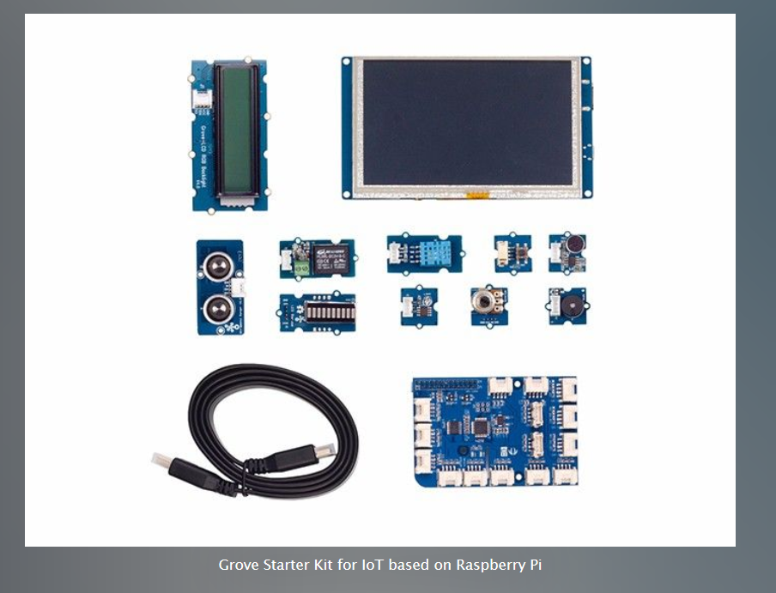
Bought from SEEED studio, looks like Dexter Industries GrovePi Base kit ($149.99-but SEEED was about $80.00 on Amazon, list price of $154.99) at
https://www.dexterindustries.com/grovepi/

System overview: http://wiki.seeedstudio.com/Grove_System/

get started: https://www.dexterindustries.com/GrovePi/get-started-with-the-grovepi/

Note: used the original DexterOS image (Stretch-based) to update GrovePi+ board firmware.
Then can use a newer Raspbian OS version, and curl the Dex-made this image available to students on OneDrive ReadOnly folder at:
https://mnscu-my.sharepoint.com/:f:/g/personal/wp8798rh_minnstate_edu/Ellwjc3DXPdBlFO2tO9Wp-gBHfqOYdgSjDwVxdjZnsoVnQ?e=9IixBd

References:
Then run the curl command to install latest grove.py library from SEEED studio:
Seeed studios wiki, info on all platforms: http://wiki.seeedstudio.com
Seeed studios info on Rpi: http://wiki.seeedstudio.com/Raspberry_Pi/
Layout for board is GrovePi Plus: http://wiki.seeedstudio.com/GrovePi_Plus/
Tutorials and documentation: https://www.dexterindustries.com/grovepi-tutorials-documentation/

Port description: https://www.dexterindustries.com/GrovePi/engineering/port-description/

Python documentation: https://www.dexterindustries.com/GrovePi/programming/python-library-documentation/

Software architecture: https://www.dexterindustries.com/GrovePi/engineering/software-architecture/

Protocol and adding custom sensors: https://www.dexterindustries.com/GrovePi/programming/grovepi-protocol-adding-custom-sensors/

HAT port layout:
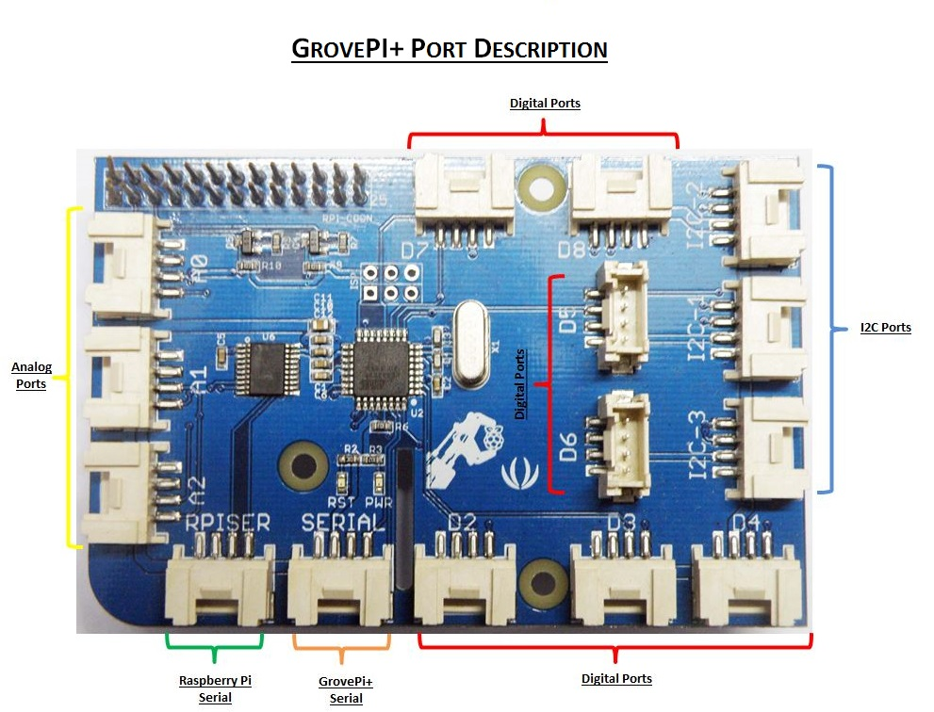

From Seeed website:
Technical details:
Dimensions | 0mm x0mm x0mm
Weight | G.W 463g
Battery | Exclude
Part List:  GrovePi+ (HAT for RPi) |  |  | 1
5 Inch HDMI Display with USB TouchScreen |  |  | 1
Grove - Relay |  |  | 1
Grove - Temp&Humi Sensor-DHT11 |  |  | 1
Grove - Ultrasonic Ranger |  |  | 1
Grove - LED Bar v2.0 |  |  | 1
Grove - Rotary Angle Sensor(P) |  |  | 1
Grove - Buzzer |  |  | 1
Grove - Sound Sensor |  |  | 1
Grove - Light Sensor v1.2 |  |  | 1
Grove – Button |  |  | 1
Grove - LCD RGB Backlight |  |  | 1
Flat HDMI Male to Male Cable (1M) |  |  | 1
Micro USB Cable (1200px) |  |  | 1
26AWG Grove Cable |  |  | 1

Connection and cable orientation:
Black/red/white/yellow
Ground/5v/data/data
For board pinouts, see: https://pinout.xyz

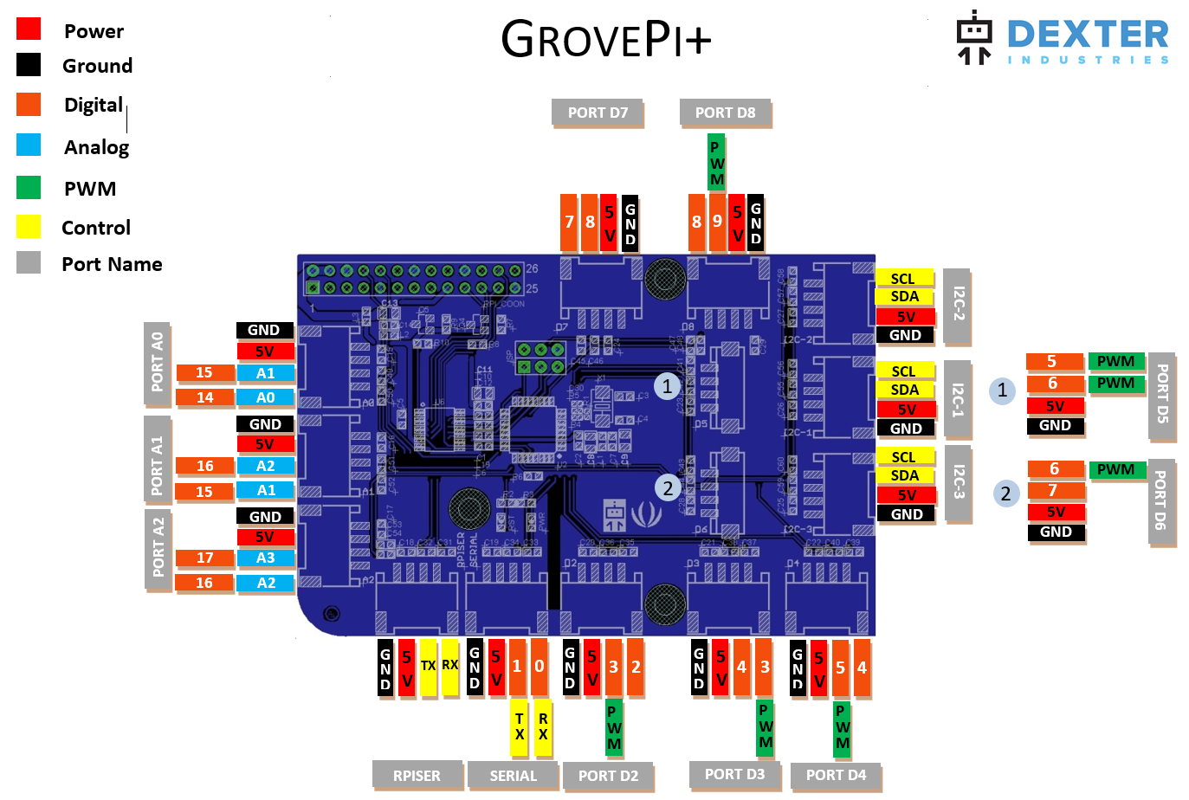

GrovePi+ Wiring Connections used in Somsen 301

Port | Sensor | Type | Notes
A0 | Light | analog
A1 | Potentiometer | analog
A2 | Microphone | analog
D2 | Ultrasonic | digital
D3 | Buzzer | digital
D4 | Button | digital
D5 | DHT11-Humidity and Temperature | digital
D6 | LED Bar | digital
D7 |  | digital | Available
D8 | Relay | digital
I2C-1 |  | I2C | Available
I2C-2 | LCD RGB | I2C
I2C-3 |  | I2C | Available
RPISER |  |  | Available
SERIAL |  |  | Available

More reference info:
Good sources of parts:
https://www.robotshop.com/en/grove.html
https://www.seeedstudio.com/category/Grove-c-1003.html
https://www.adafruit.com/

